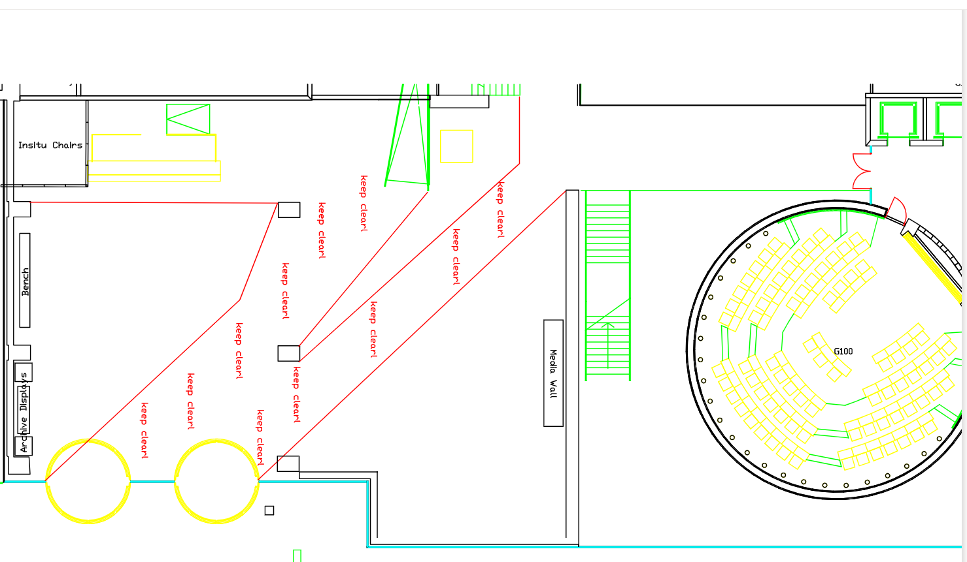

6
6
5
i
Map
5
Art?
3
4
Chair
7
2

7
Bridge

8
1
1

9 - comet
10
10

9 - Comet

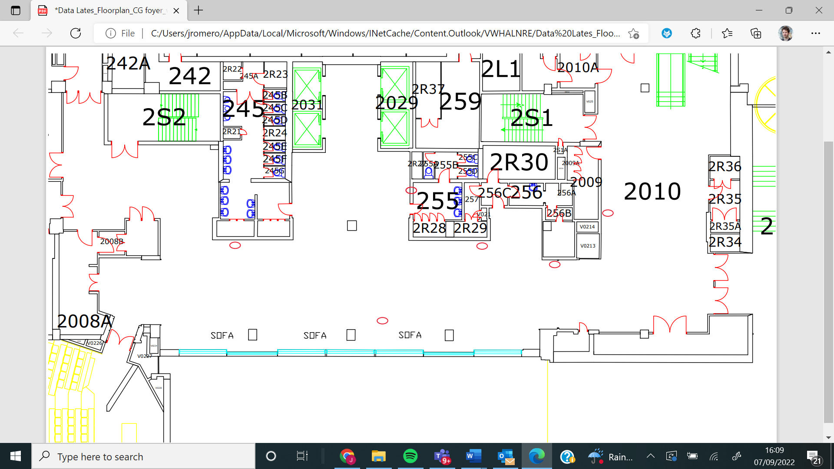
ip

Shields

20 Hobson
20 Hobson
16 Migeul
17 Higgins
22 – Weirdest
23 – Quantum tech
15 Sonia
19 Laima
Laima
18 Malaria
14 Maths
21 Flanagan

